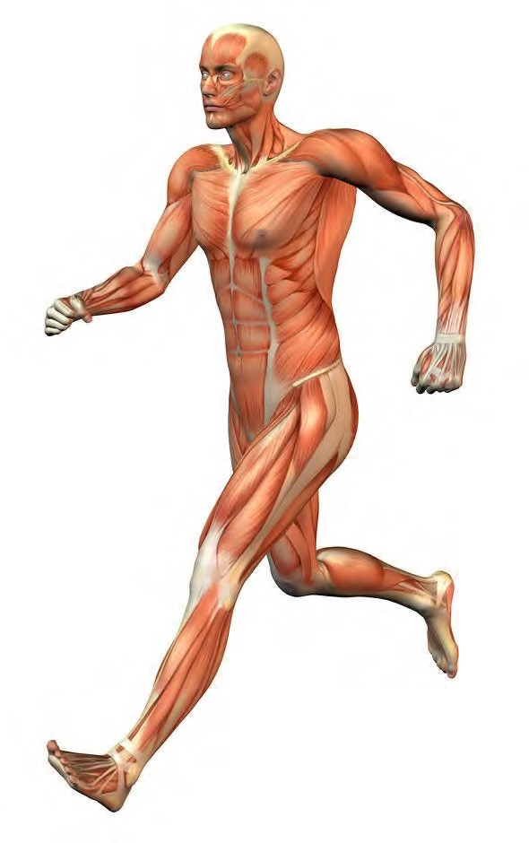THE MUSCULAR SYSTEM COMPILED BY HOWIE BAUM **1**

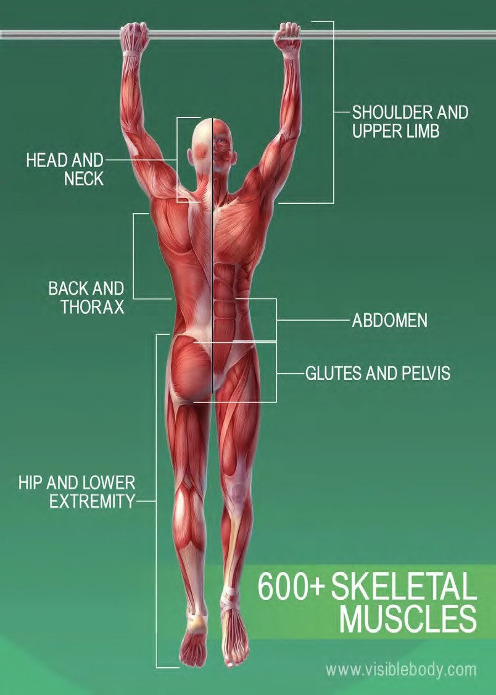

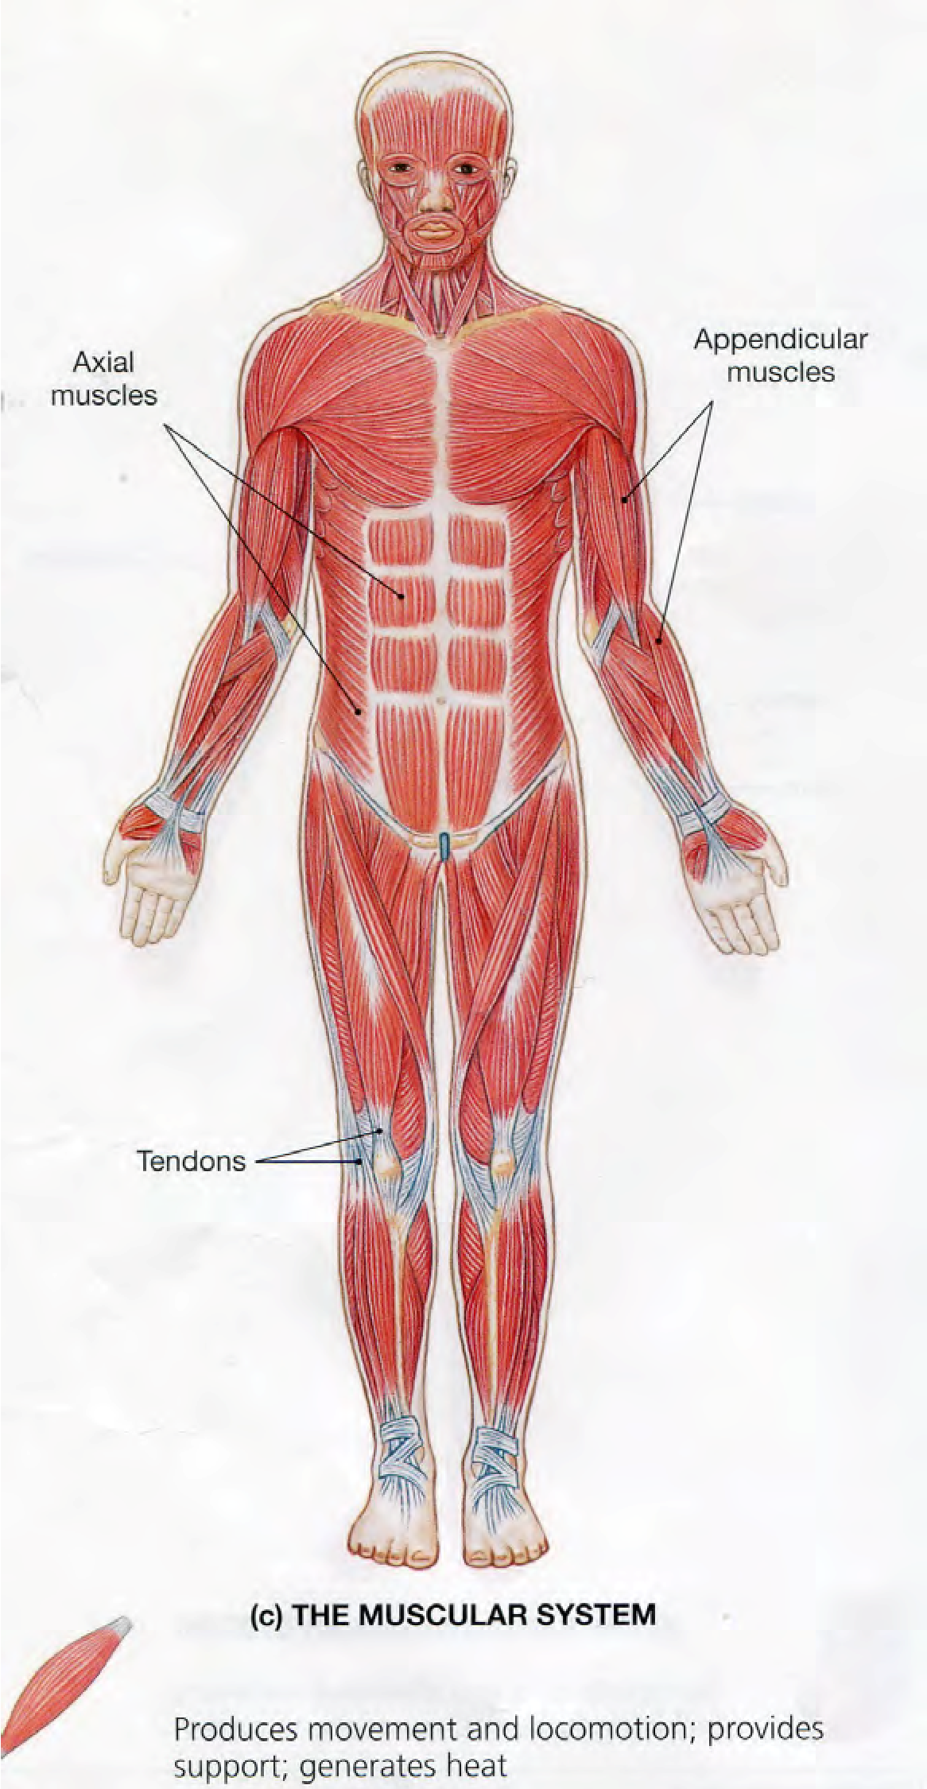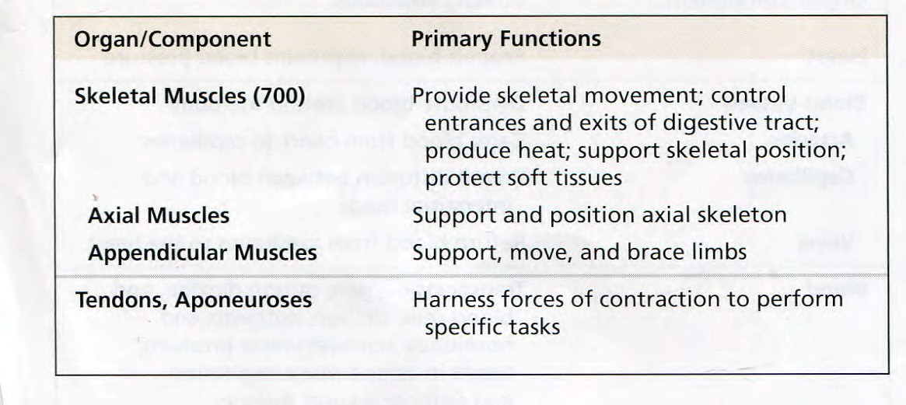

Muscles make up the bulk of the body

and account for 1/3 of its weight.!!

Blood vessels and nerves run to every

muscle, helping control and regulate each

muscle’s function.

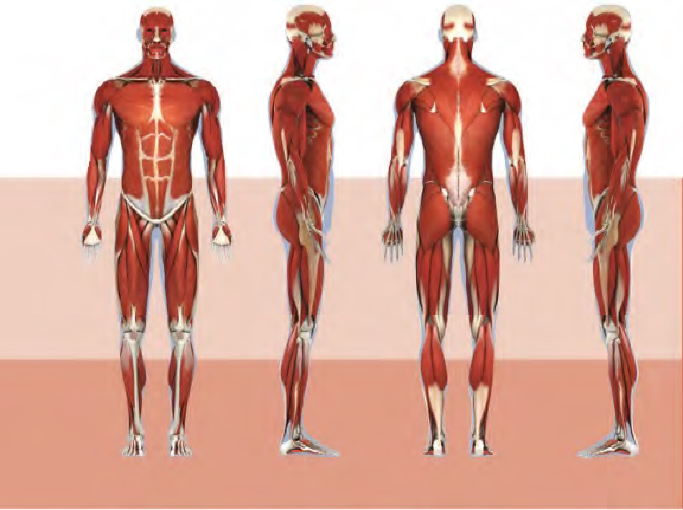

**The muscular system creates body heat** and also moves the:

* 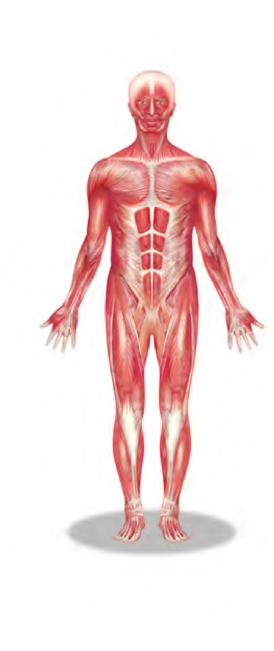Bones of the Skeletal system
* Food through Digestive system
* Blood through the Circulatory system
* Fluids through the Excretory system **MUSCLE TISSUE**

# **The body has 3 main types of muscle tissue 1) Skeletal, 2) Smooth, and 3) Cardiac**

**SKELETAL MUSCLE SMOOTH MUSCLE CARDIAC MUSCLE**

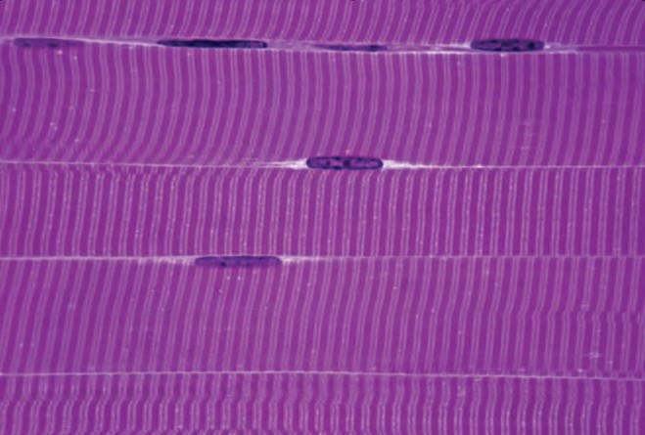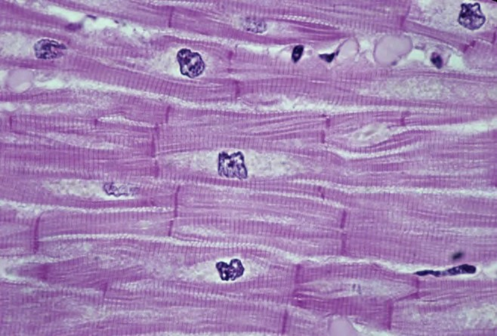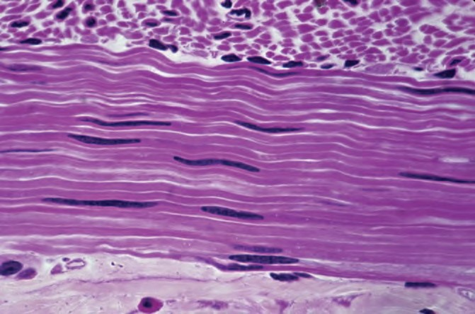

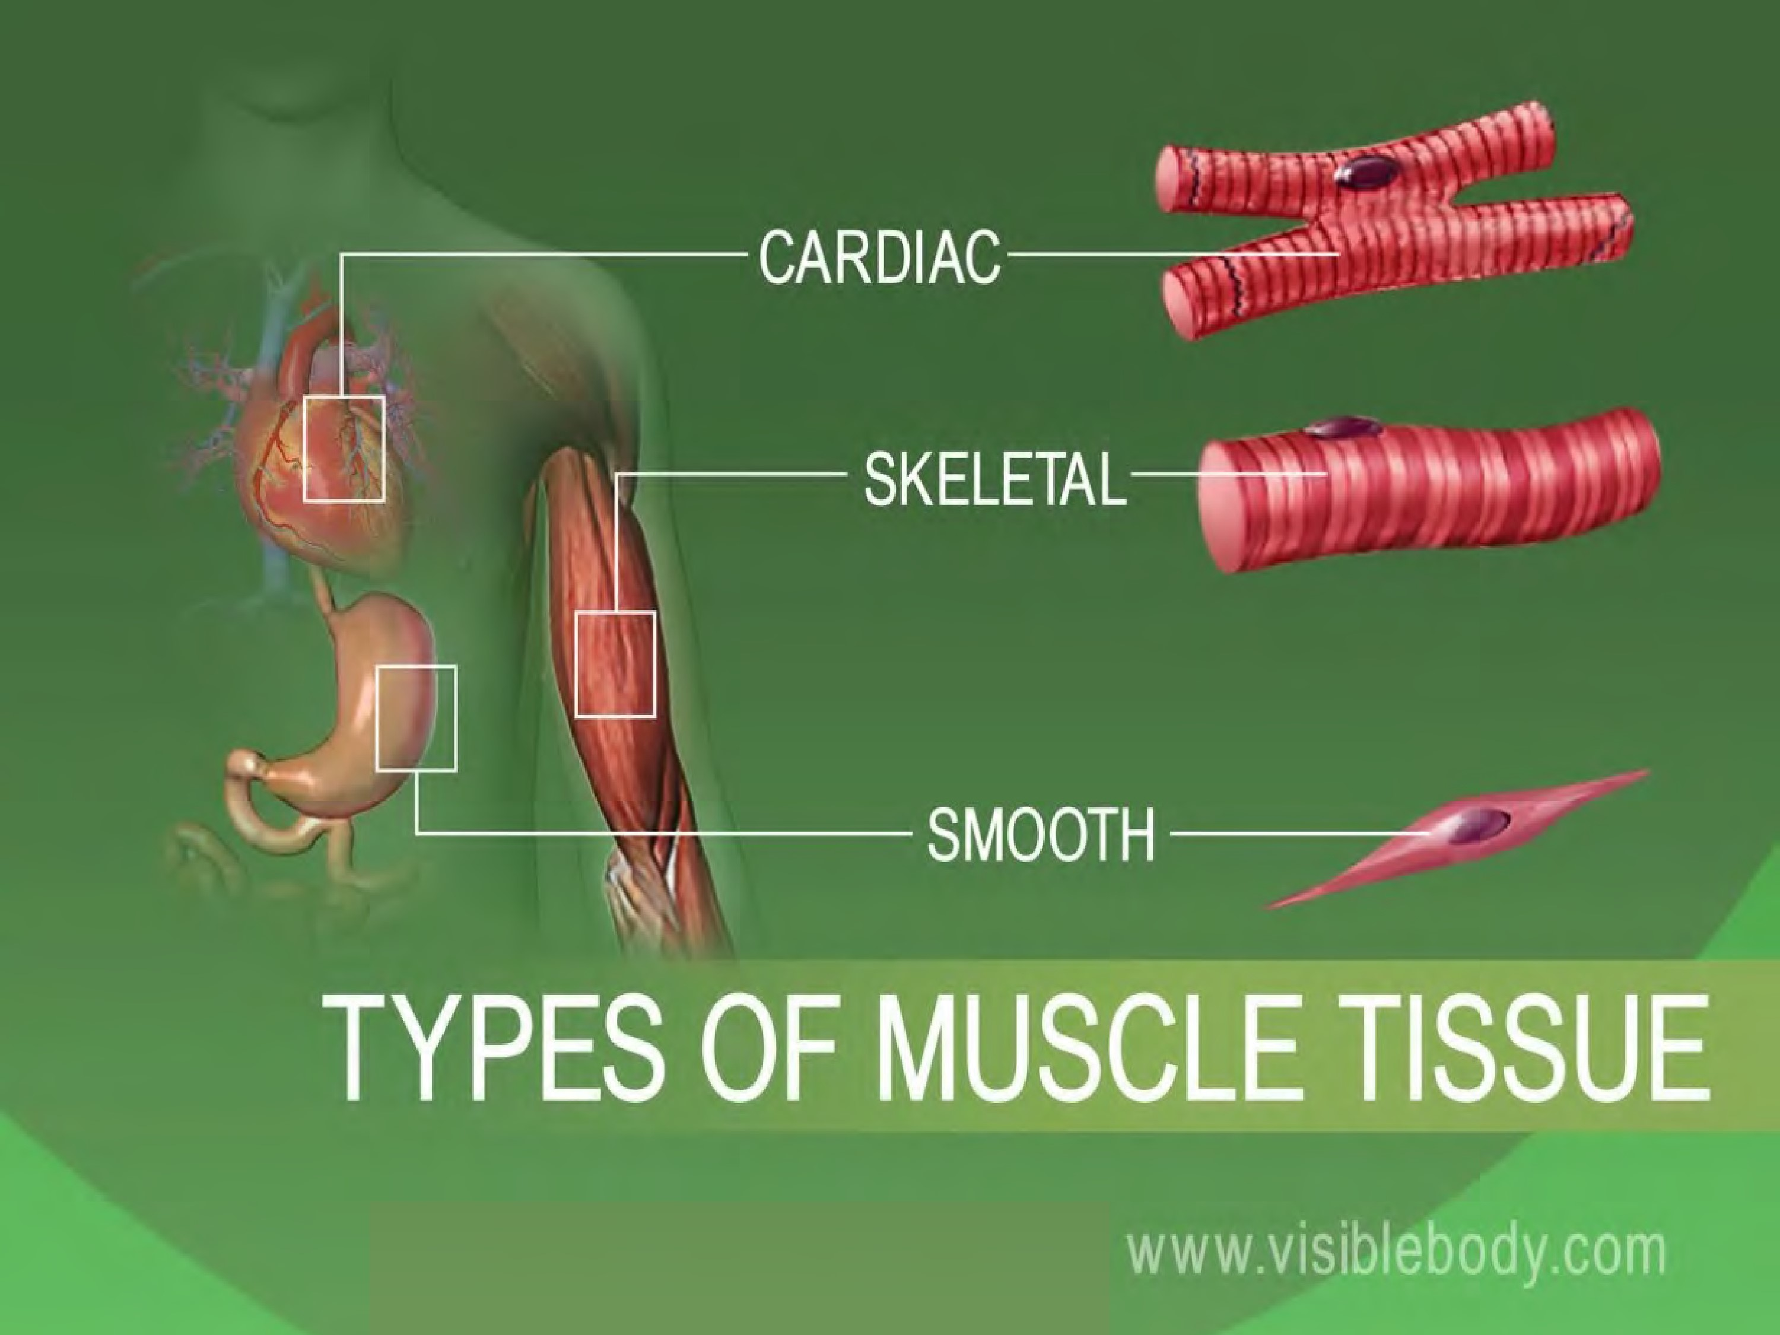

Skeletal muscles attach to and move bones by contracting and relaxing in response to voluntary messages from the nervous system.

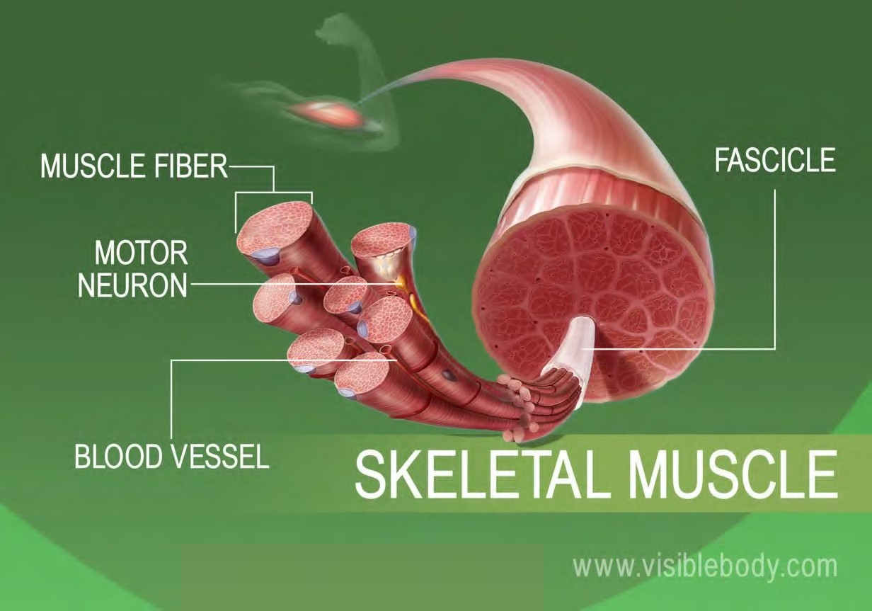Skeletal muscle tissue is composed of long cells called muscle fibers that have a striated appearance.

Muscle fibers are organized into bundles supplied by blood vessels and innervated by motor neurons.

**Muscle structure**

Skeletal (striated or voluntary) muscle consists of densely packed groups of hugely elongated cells known as myofibers.

These are grouped into bundles (fascicles).

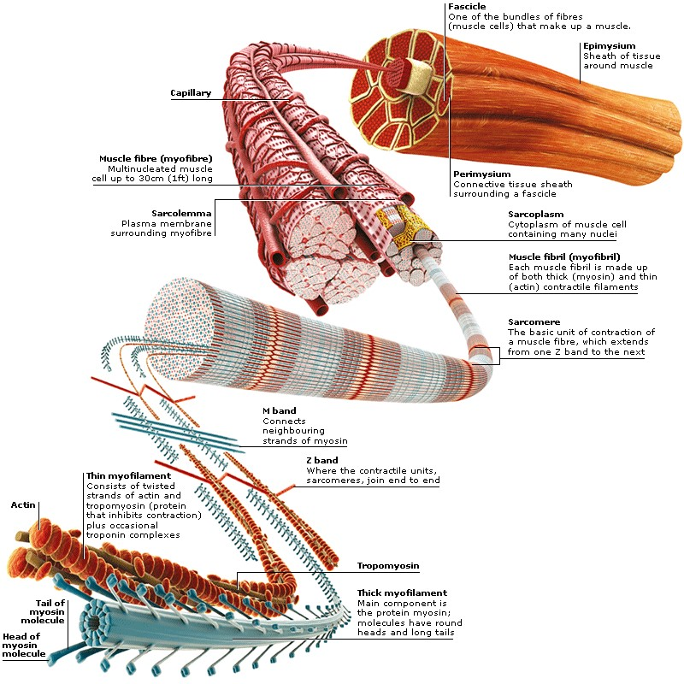A typical myofiber is 2–3 centimeters ( 3/4–1 1/5 in) long and 0.05millimeters (1/500 inch) in diameter and is composed of narrower structures – myofibrils. These contain thick and thin myofilaments made up mainly of the proteins actin and myosin. Numerous capillaries keep the muscle supplied with the oxygen and glucose needed to fuel contraction.

# Skeletal Muscles

* Skeletal muscles attach to bones by tendons (connective tissue) and enable movement.
* 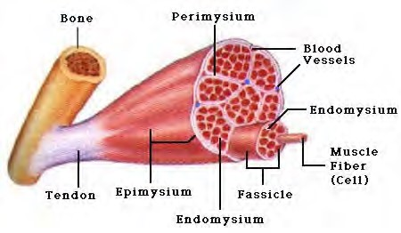Skeletal muscles are mostly voluntary

Feel the back of your ankle to feel your Achilles tendon - the largest tendon in your body.

The typical male body contains approximately 640 muscles, which compose around two-fifths of its weight.

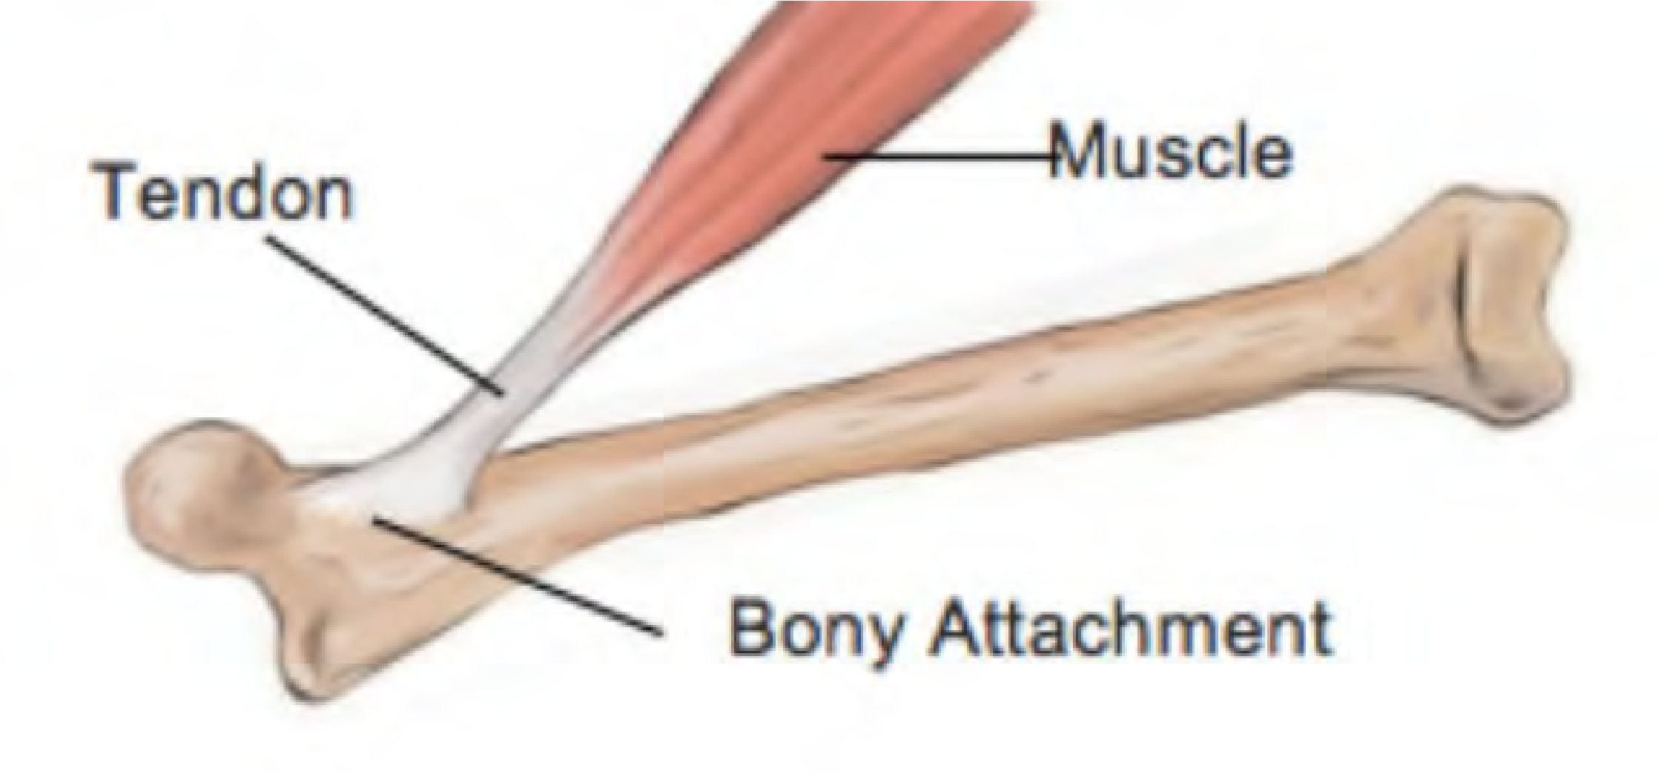The same number in a female body make up a slightly smaller proportion.

A typical muscle spans a joint and tapers at each end into a fibrous tendon anchored to a bone. Some muscles divide to attach to different bones.

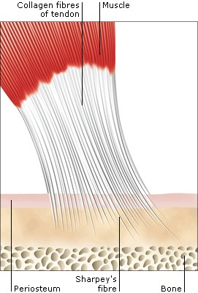**TENDONS**

Tendons are tough, fibrous cords of connective tissue that link skeletal muscles to bones.

Within them, Sharpey’s fibers pass through the bone covering (periosteum) to embed in the bone.

Tendons in the hands and feet are enclosed in selflubricating sheaths to protect them from rubbing against the bones.

From the hand bones, tendons extend upwards to muscles near the elbow.

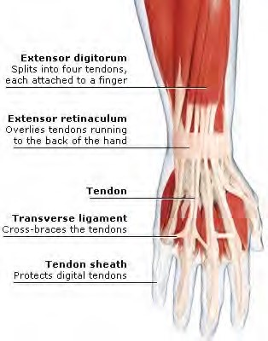Tendons and Tendon Sheaths in the hand.

## SKELETAL MUSCLES

**Skeletal muscles** are also known as voluntary muscles, since we control their actions at will, and as striated muscles, from their microscopic appearance.

In the muscular system, skeletal muscles are connected to the skeleton, either to bone or to connective tissues such as ligaments.

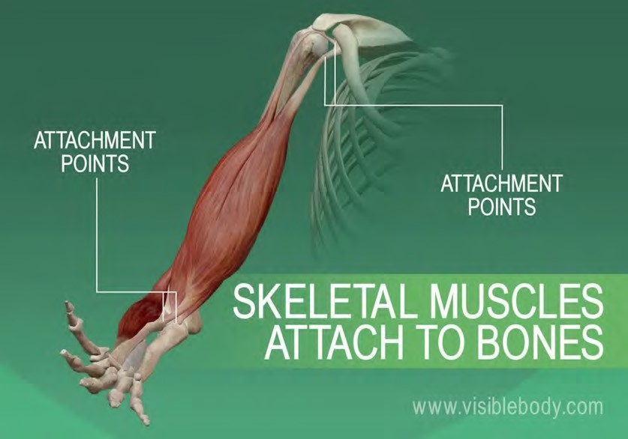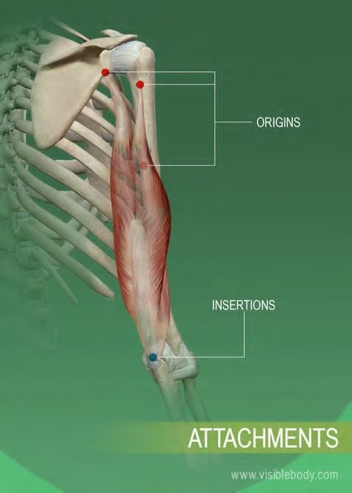

Muscles are always attached at two or more places.

When the muscle contracts, the attachment points are pulled closer together; when it relaxes, the attachment points move apart.

A second type is smooth muscle, in the walls of body parts such as the airways, stomach, Alimentary canal, and blood vessels.

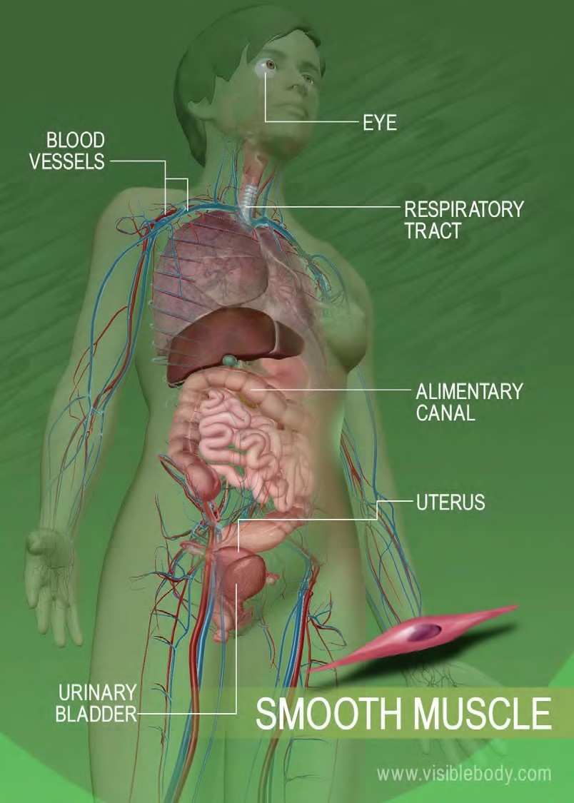This is called involuntary muscle, because it works automatically rather than under conscious control, or smooth muscle, from its magnified appearance

• Smooth muscle lines organs and is involuntary.

* moves food through digestive organs
* empties liquid from the bladder
* 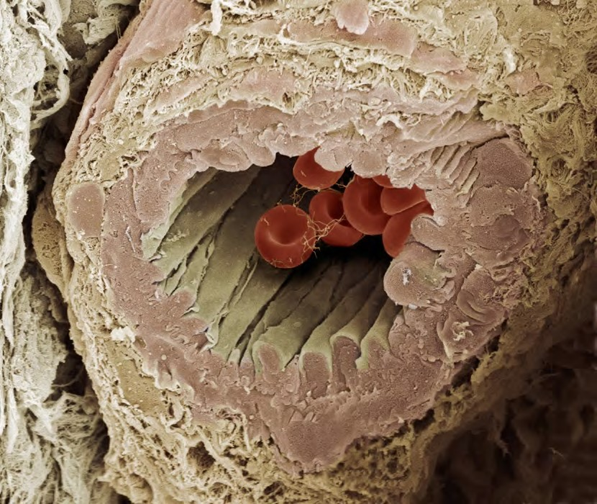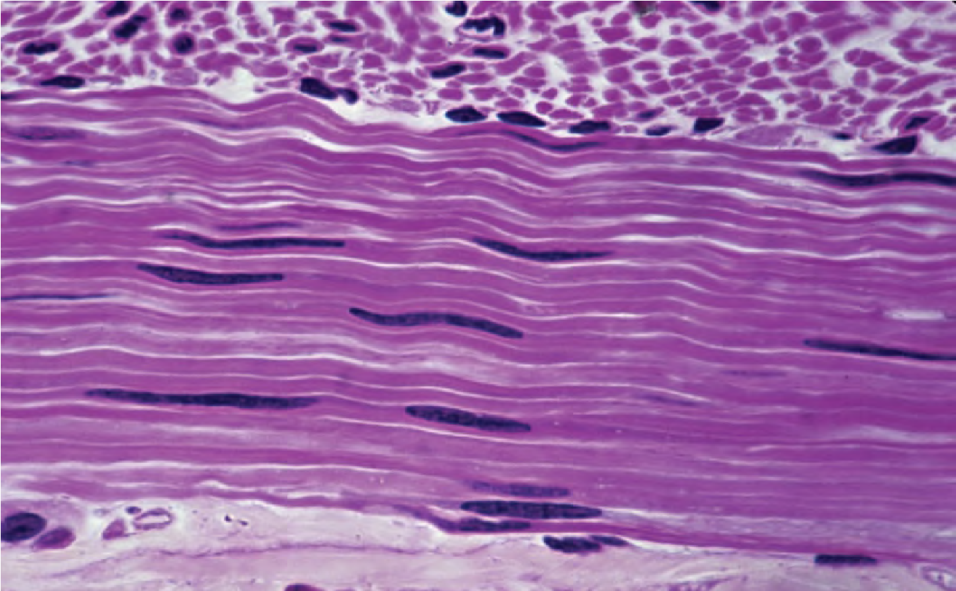controls width of the blood vessels

**Smooth muscle around this artery allows the artery to regulate blood flow by shrinking and expanding.**

**SMOOTH MUSCLE**

The third type is **cardiac muscle**, making up the walls of the heart.

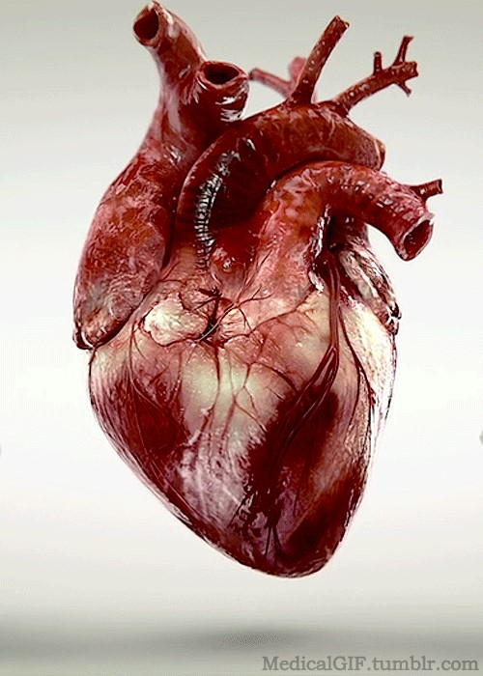It is part of both the Muscular System and the Circulatory System.

It is responsible for circulating blood throughout the body.

It has its own pacemaker for rhythmic beating.

The heart wall is composed of three layers.

The middle layer, the myocardium, is responsible for the heart’s pumping action.

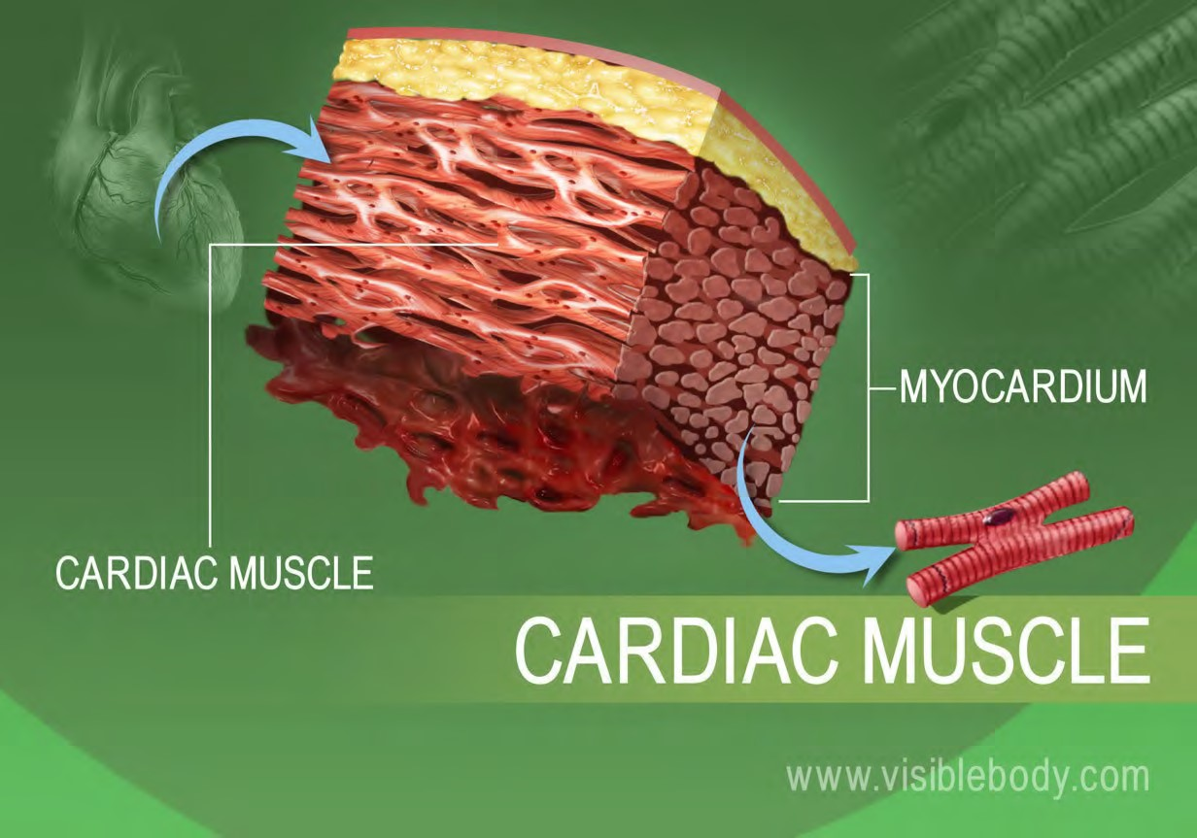Cardiac muscle, found only in the myocardium, contracts in response to signals from the cardiac conduction system to make the heart beat.

Cardiac muscle is made from cells called cardiocytes.

• Cardiac muscle is found only in the heart.

* pumps blood throughout body
* 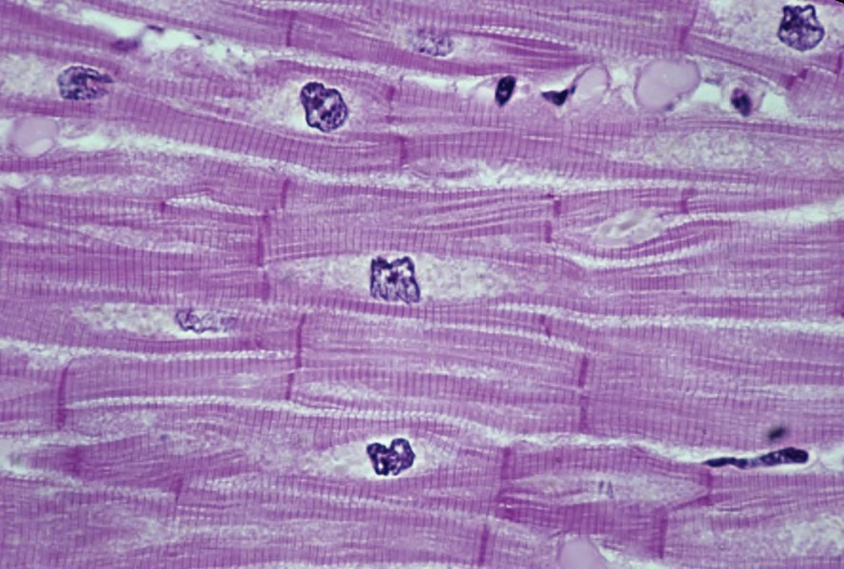contains more mitochondria than skeletal muscle cells

**CARDIAC MUSCLE**

**HOW DO SKELETAL MUSCLES MOVE?**

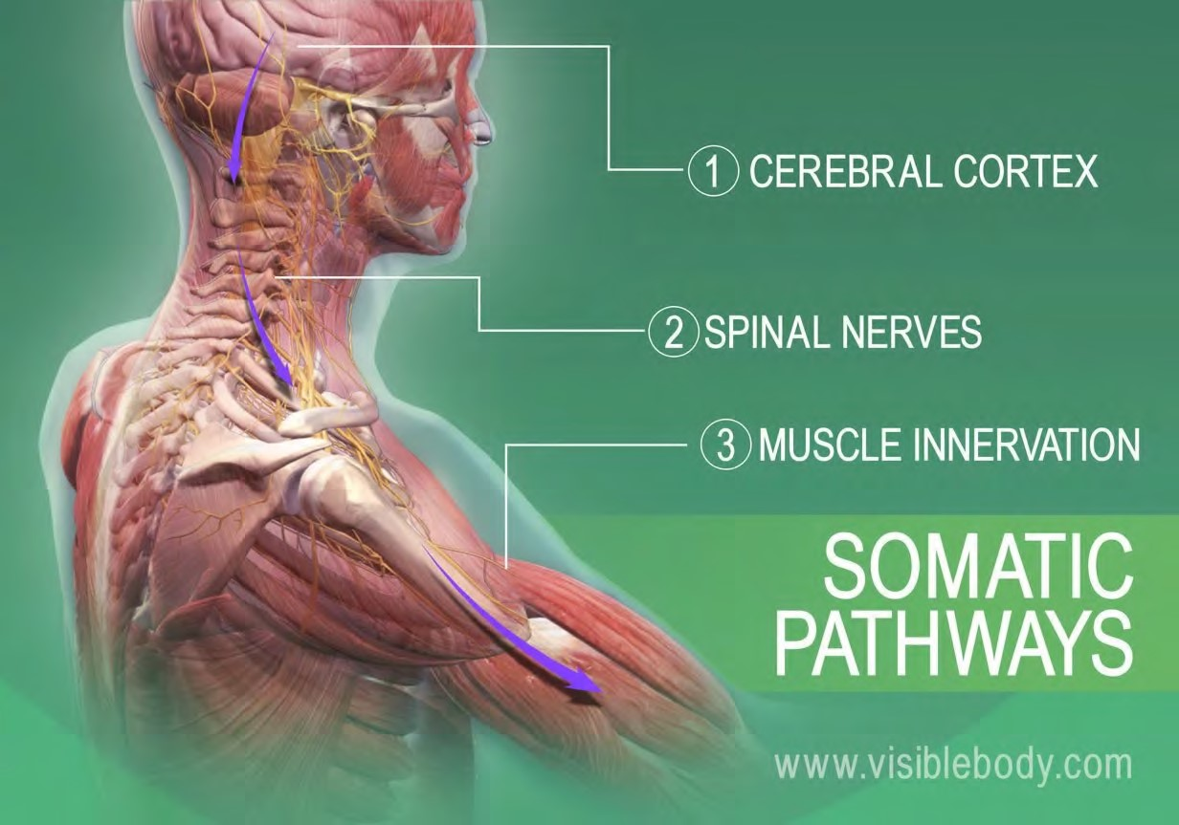It happens when the muscular system and the nervous system work together: Somatic signals are sent from the cerebral cortex to nerves associated with specific skeletal muscles.

Most signals travel through spinal nerves that connect with nerves that innervate skeletal muscles throughout the body.

Muscle contraction begins when the nervous system generates a signal.

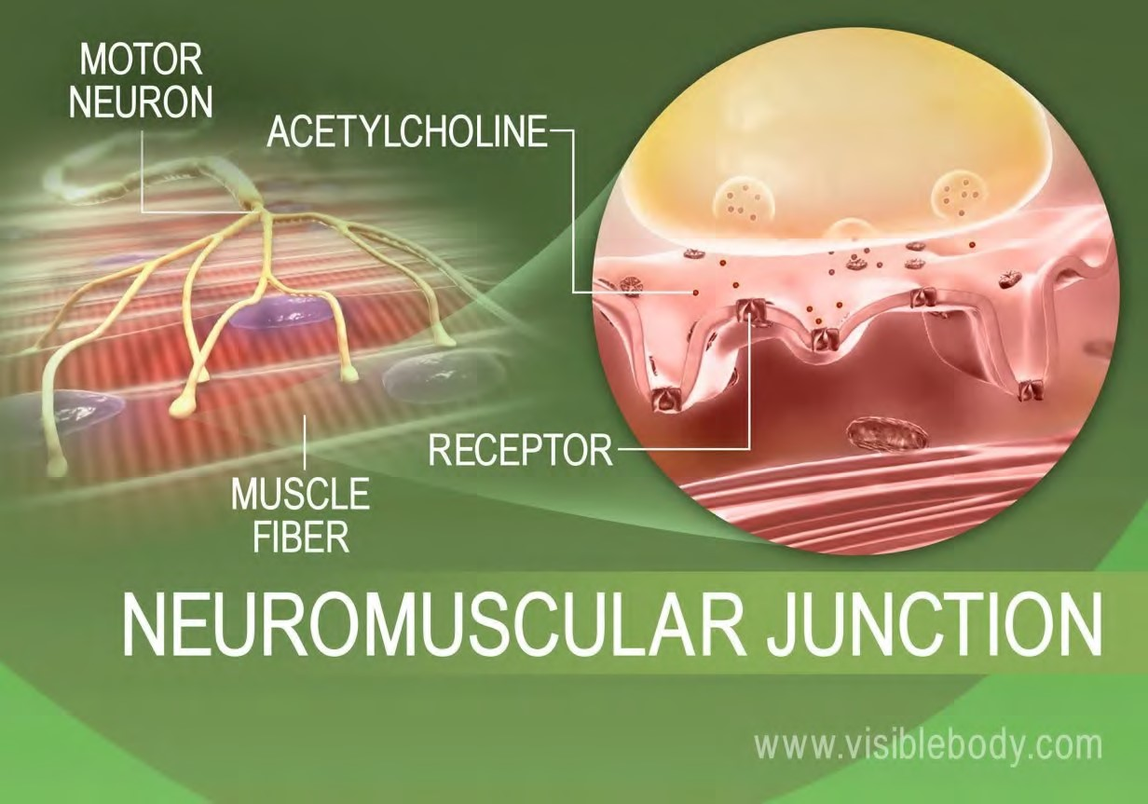The signal, an impulse called an action potential, travels through a type of nerve cell called a motor neuron.

The neuromuscular junction is the name of the place where the motor neuron reaches a muscle cell.

Skeletal muscle tissue is composed of cells called muscle fibers.

The top image is of a brain neuron sending an electronic signal to a motor neuron, shown below.

When the nervous system signal reaches the neuromuscular junction a chemical message is released by the motor neuron.

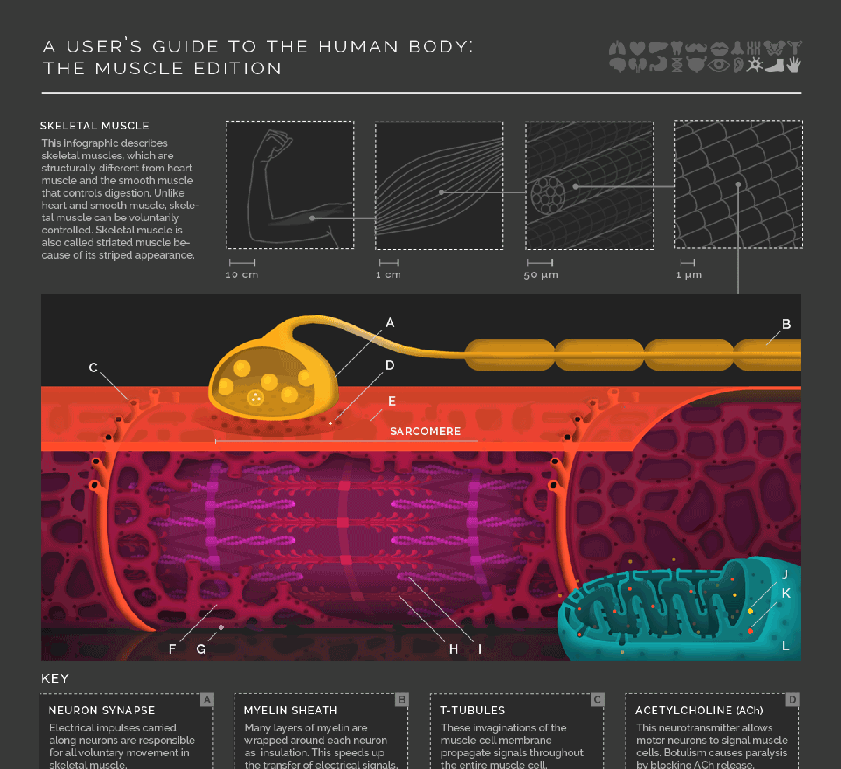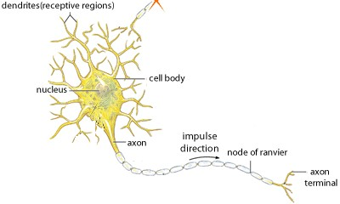

The chemical message, a **neurotransmitter called acetylcholine**, binds to receptors on the outside of the muscle fiber. That starts a chemical reaction within the muscle, to make it contract.

A multistep molecular process within the muscle fiber begins when acetylcholine binds to receptors on the muscle fiber membrane.

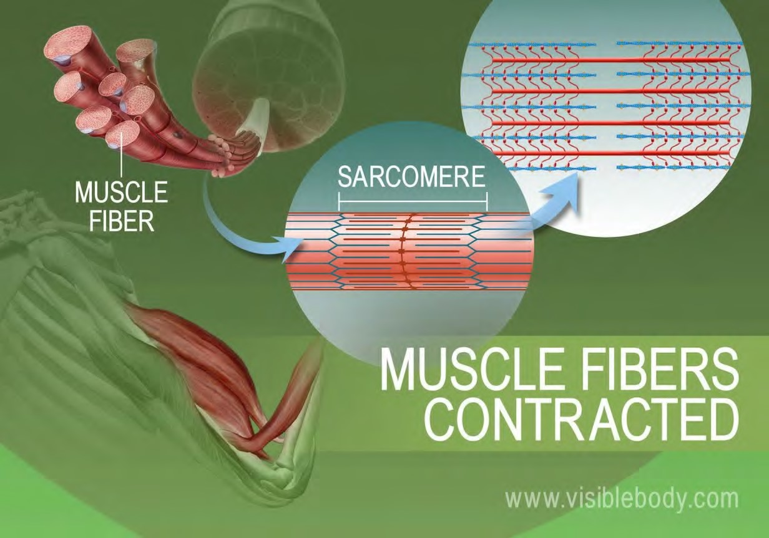The proteins inside muscle fibers are organized into long chains that can interact with each other, reorganizing to shorten and relax.

When acetylcholine reaches receptors on the membranes of muscle fibers, membrane channels open and the process that contracts a relaxed muscle fibers begins.

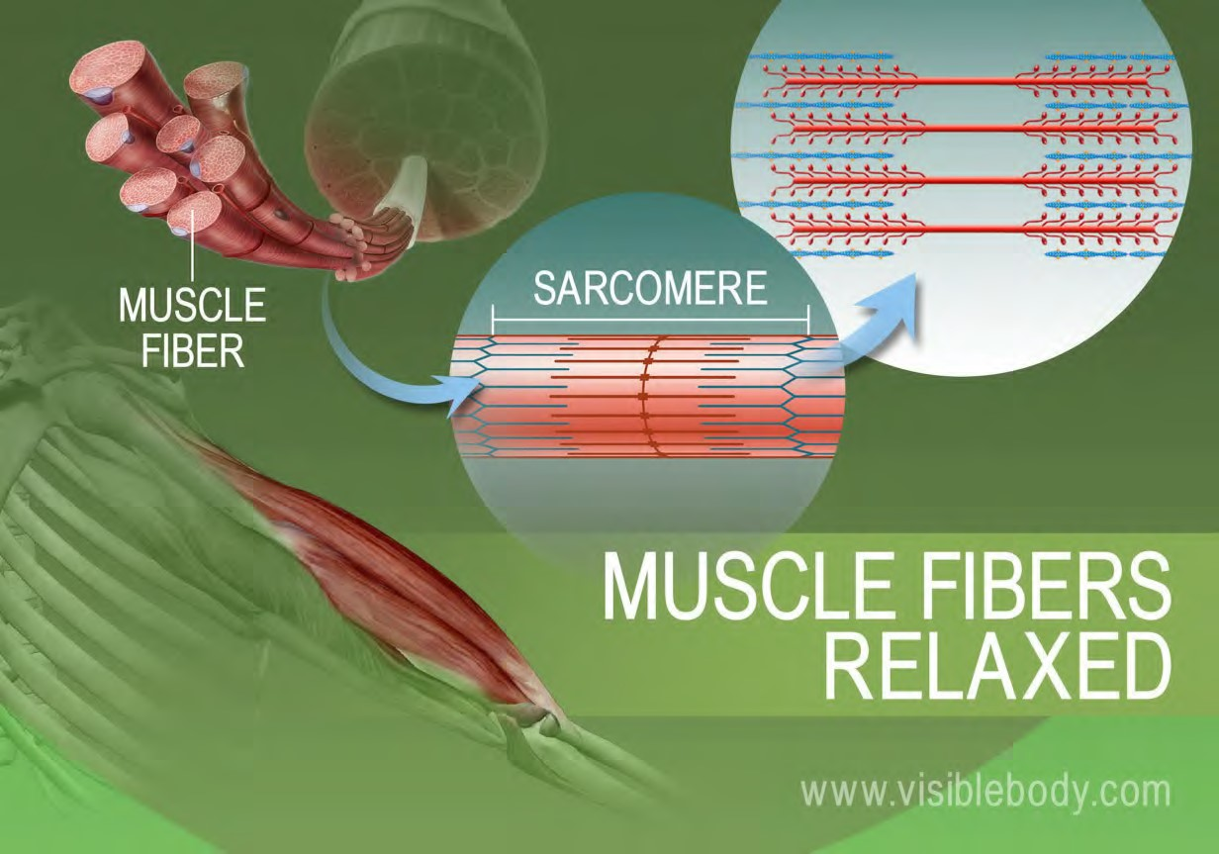When the stimulation of the motor neuron providing the impulse to the muscle fibers stops, the chemical reaction that causes the rearrangement of the muscle fibers proteins is stopped.

This reverses the chemical processes in the muscle fibers and the muscle relaxes.

**Muscle pairs:**

Muscles are grouped together in pairs on your skeleton

**Muscles can’t push - they only contract and pull the bones to which they are anchored.**

**Relaxed or contracted:**

When one muscle of a pair contracts, the other relaxes

**Pulling muscles:**

Skeletal muscles only pull in one direction. For this reason they always come in pairs. When one muscle in a pair contracts, to bend a joint for example, its partner then contracts and pulls in the opposite direction to straighten the joint out again.

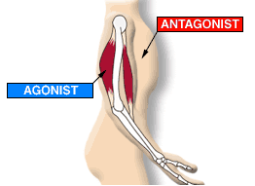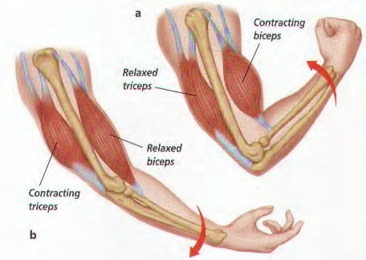

An example of how the 2 sets of

arm muscles move to pull the

bone, on one side and then the

other, depending on how the arm

is intended to move.

**FACIAL MUSCLES AND**

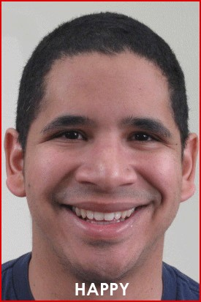**THE SHOWING OF OUR EMOTIONS**

To steady and move the head and to move facial features such as the eyebrows, eyelids, and lips, the muscles of the face, head and neck interact.

The musculature involved is highly complex, allowing for a huge range of facial expressions.

## FACIAL MUSCLES

Some facial muscles are anchored to bones.

Others are joined to tendons or to dense, sheet-like clusters of fibrous connective tissue called aponeuroses.

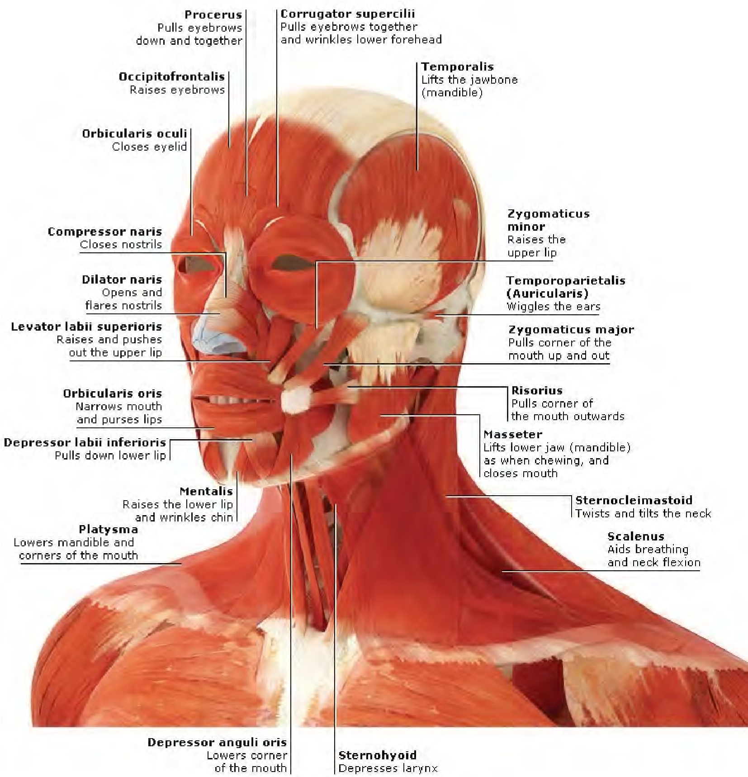This means, that some facial muscles are joined to each other.

Many of these muscles have their other end inserted into deeper layers of the skin. The advantage of this complex system is that even a slight degree of muscle contraction produces movement of the face’s skin, which reveals itself as a show of expression or emotion.

## LAUGHTER LINES

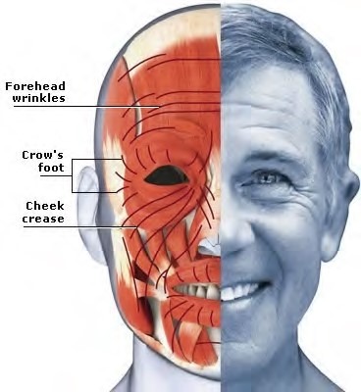Healthy young skin contains resilient fibers made of the protein elastin which help it return to its original position, for example, after smiling.

With increasing age, the elastin degenerates and the skin’s dermis becomes more loosely attached to the muscle beneath.

This causes wrinkles as the skin can no longer stretch or shrink easily.

Initially “crow’s feet” radiate from the corners of the eyes. These are followed by lines around the brow and mouth, in front of the ears, between the eyebrows, on the chin and bridge of the nose.

Facial expressions

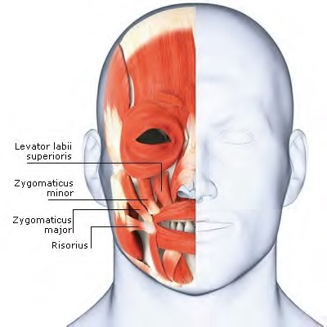Facial expressions are among our most important methods of non-verbal communication.

The facial musculature enables many subtle nuances of appearance that convey an enormous variety of emotions.

A smile often indicates pleasure, and a frown the opposite – but not always.

The smile is a highly ambiguous and versatile expression, which

can also convey relief or pity, or

widen into a grin for sarcastic SMILING disapproval.

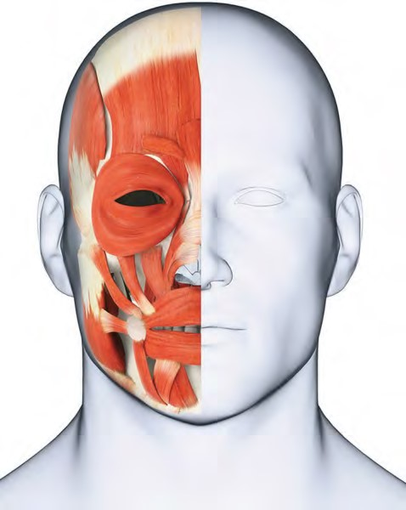RELAXED NEUTRAL POSITION

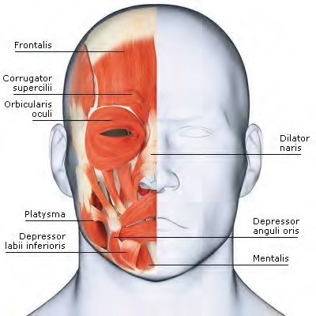Likewise, a frown can articulate various feelings, including disappointment and confusion.

In addition to the mouth, other regions of the face are involved to add shades of meaning.

**Muscular System Pathologies:**

## Common Disorders and Conditions

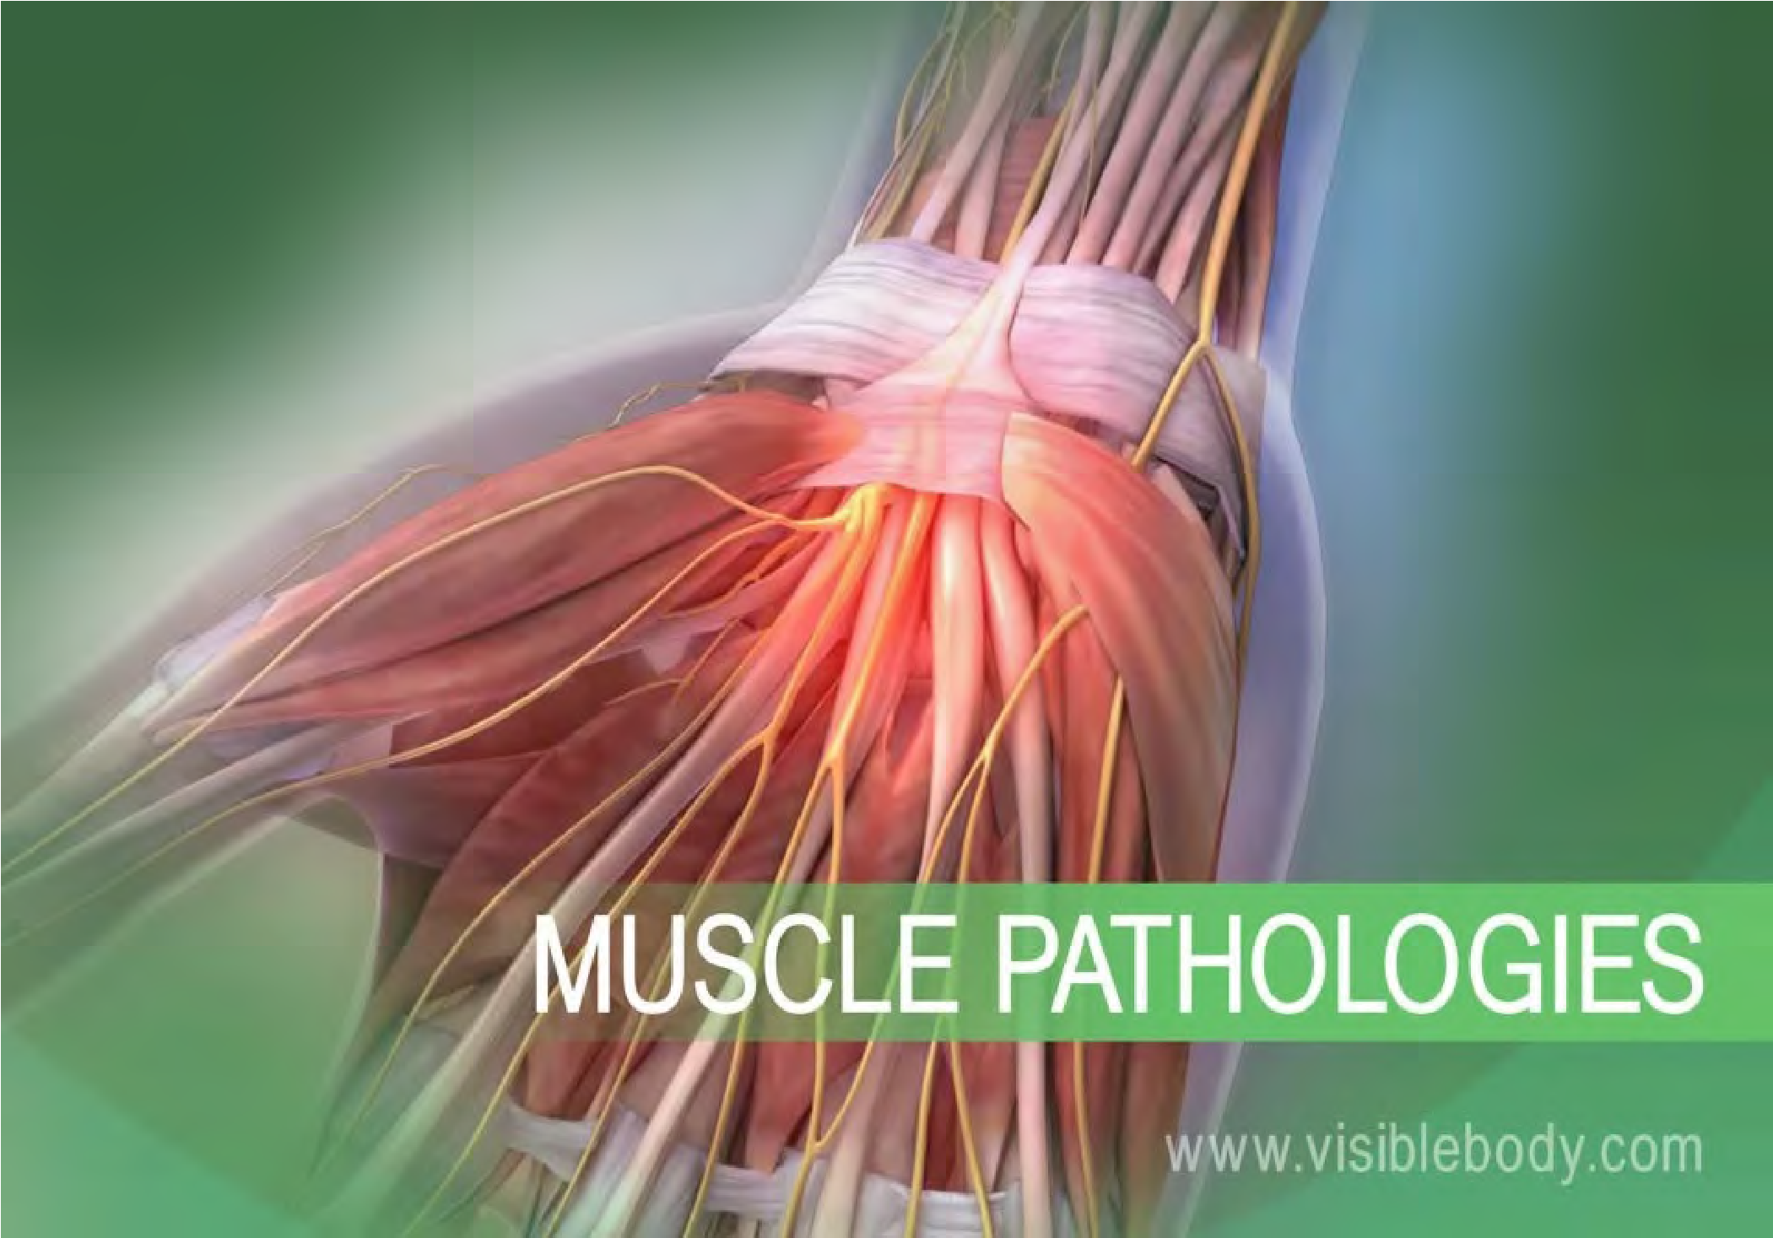Muscles allow us to move, but sometimes the wear and tear that comes from moving our bodies can lead to disorders of the muscular system.

Below are some of the most common muscular pathologies.

The carpal tunnel is the passageway in the wrist where the median nerve and flexor tendons pass through a narrow opening.

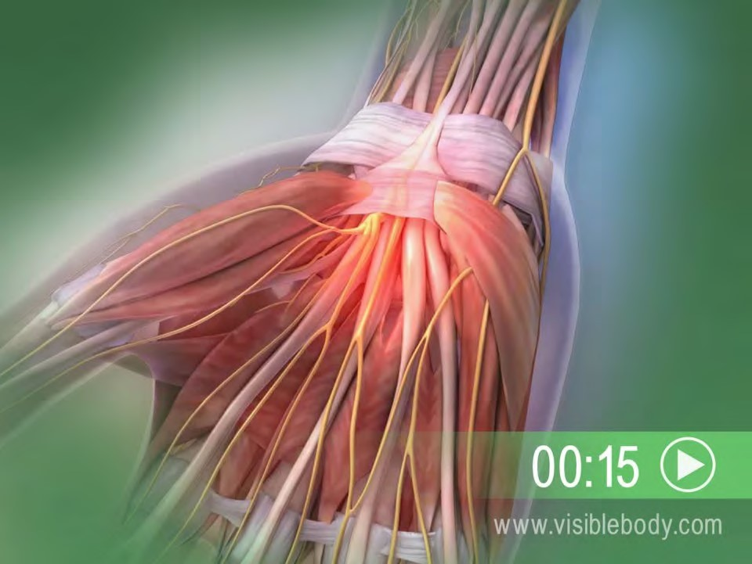**Carpal tunnel syndrome**, which is also called median nerve compression, occurs when the tendons become inflamed, causing compression of the median nerve.

Symptoms include pain, numbness, and eventual weakness in the hand. Carpal tunnel syndrome can occur for a variety of reasons including hereditary predisposition, repetitive movements, diabetes, or thyroid disorders.

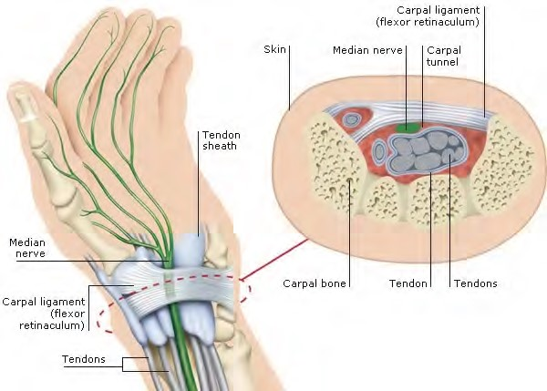

The carpal tunnel is between the carpal ligament (flexor

retinaculum), which restrains and aligns the tendons that move the hand and fingers, and the carpal bones of the wrist. Tendons in their sheaths slide through this passageway, adjacent to the median nerve.

If you do a lot of typing or other repetitive motions over a long period of time, you can get Carpal Tunnel Syndrome in one or both wrists.

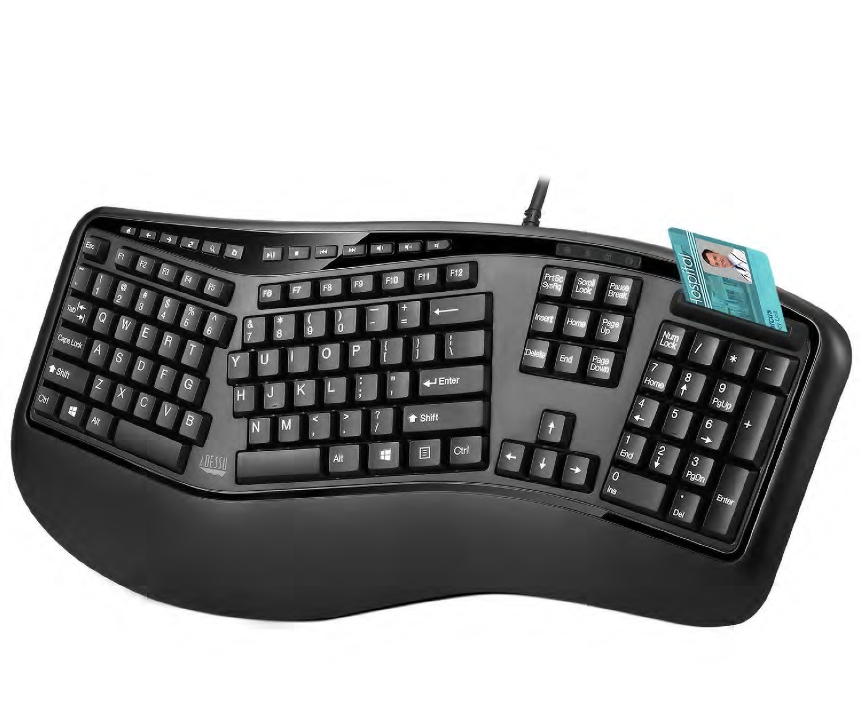

To minimize the problem if you type a lot, an Ergonomic

keyboard is recommended.

## BURSITIS

Bursae are small fluidfilled sacs that cushion the bones, tendons, and muscles near the joints.

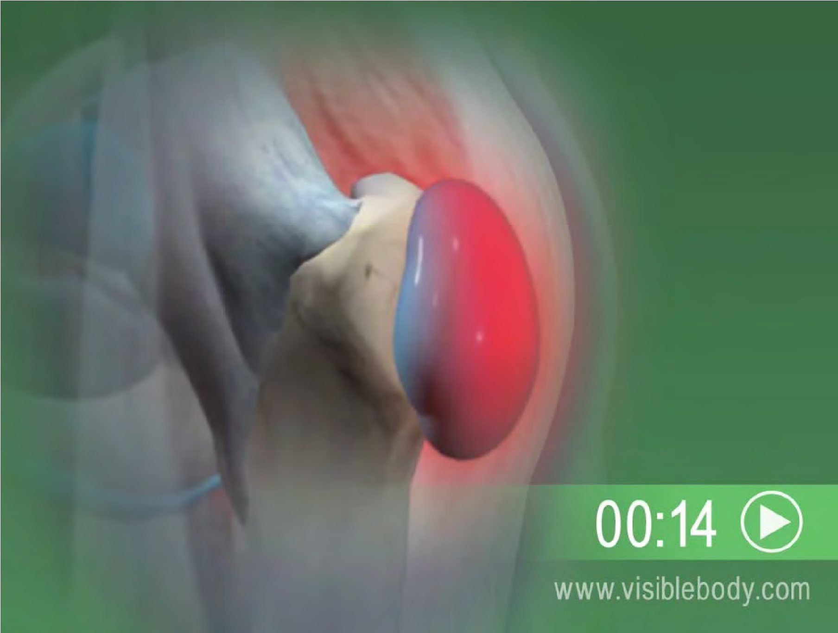Bursitis occurs when bursae become red and inflamed, causing pain.

This condition often occurs near joints that perform frequent repetitive motion, such as the shoulder, elbow, hip, and knee.

And Finally, Some Questions

* Muscle Trivia…

|  |
| --- |
| Approximately 640 |

* How many muscles are in the average adult human body?
* What is the strongest muscle in the body?

Debatable, but many say the masseter (jaw).

* What is the largest muscle in the body?

The gluteus maximus in your rear end

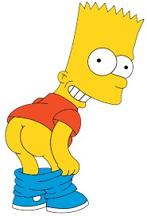

THE END !!